1.

**SELECT** *

**FROM** flights

**INNER** **JOIN** aircrafts **ON** flights.aircraft_code = aircrafts.aircraft_code

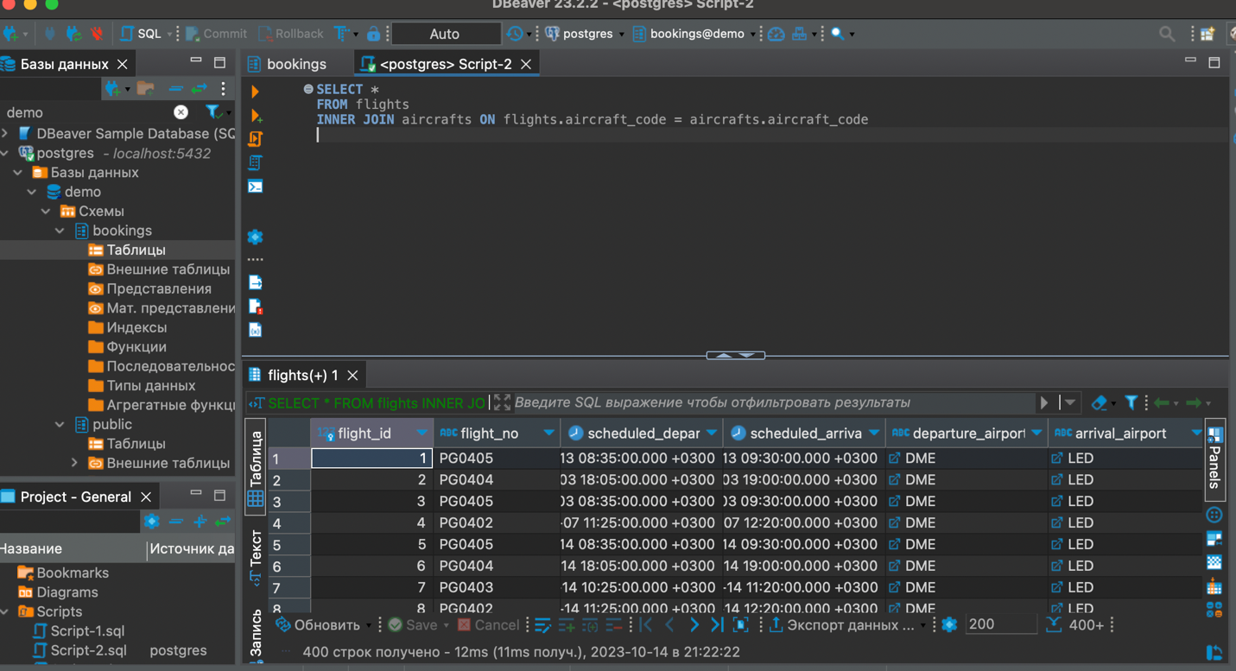

2.

**SELECT** *

**FROM** aircrafts

**where** **range** > 5000

**order** **by** "range" **desc**

**limit** 10

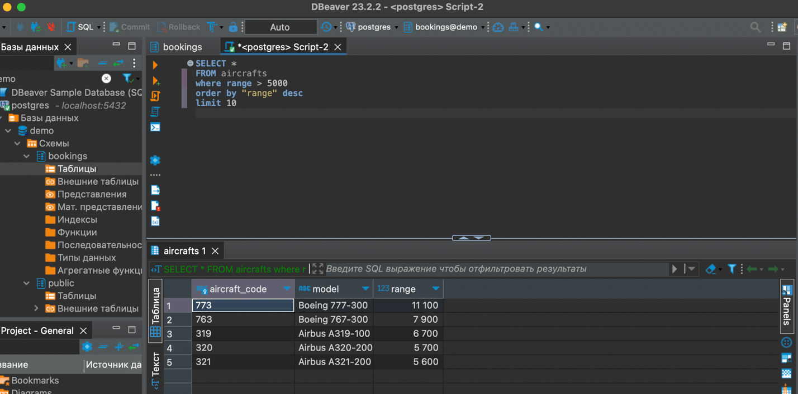

3.

**SELECT**

a.model,

**COUNT**(f.flight_no) **AS** FlightCount,

**MIN**(f.scheduled_arrival) **AS** MinArrival,

**MAX**(f.scheduled_arrival) **AS** MaxArrival

**FROM**

aircrafts a

**LEFT** **JOIN**

flights f **ON** a.aircraft_code = f.aircraft_code

**GROUP** **BY**

a.model

**ORDER** **BY**

a.model

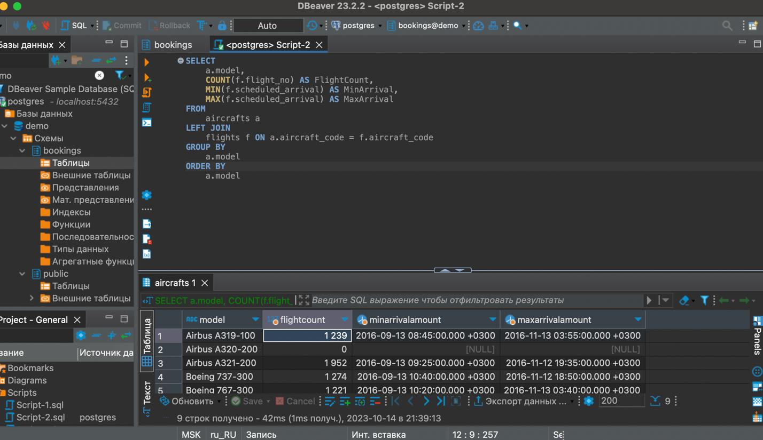

4.

**SELECT**

aircrafts.model, seats.seat_no, seats.fare_conditions ,

flights.scheduled_departure, flights.actual_departure

**FROM** aircrafts

**INNER** **JOIN** seats **ON** aircrafts.aircraft_code = seats.aircraft_code

**RIGHT** **JOIN** flights **ON** aircrafts.aircraft_code = flights.aircraft_code

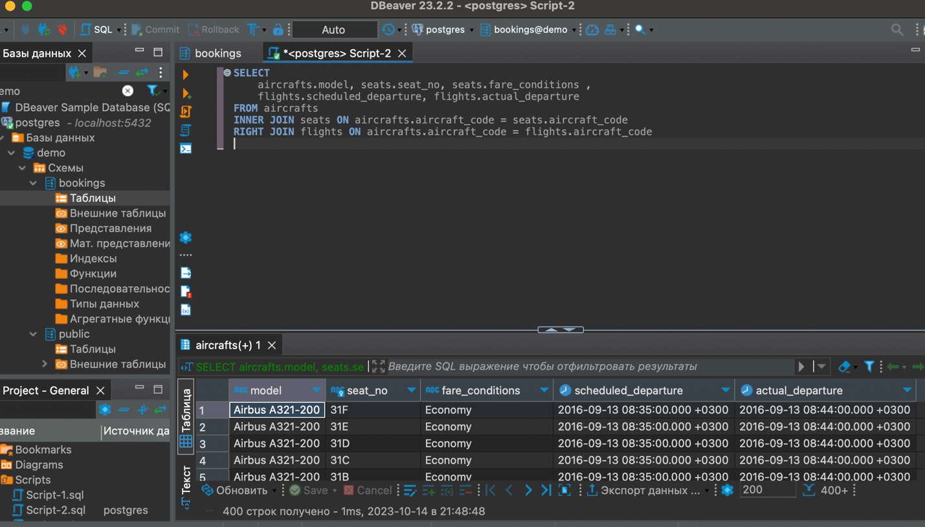

5.

**CREATE** **VIEW** MyTable **as**

**SELECT** *

**FROM** aircrafts

**where** **range** > 5000

**order** **by** "range" **desc**

**limit** 10

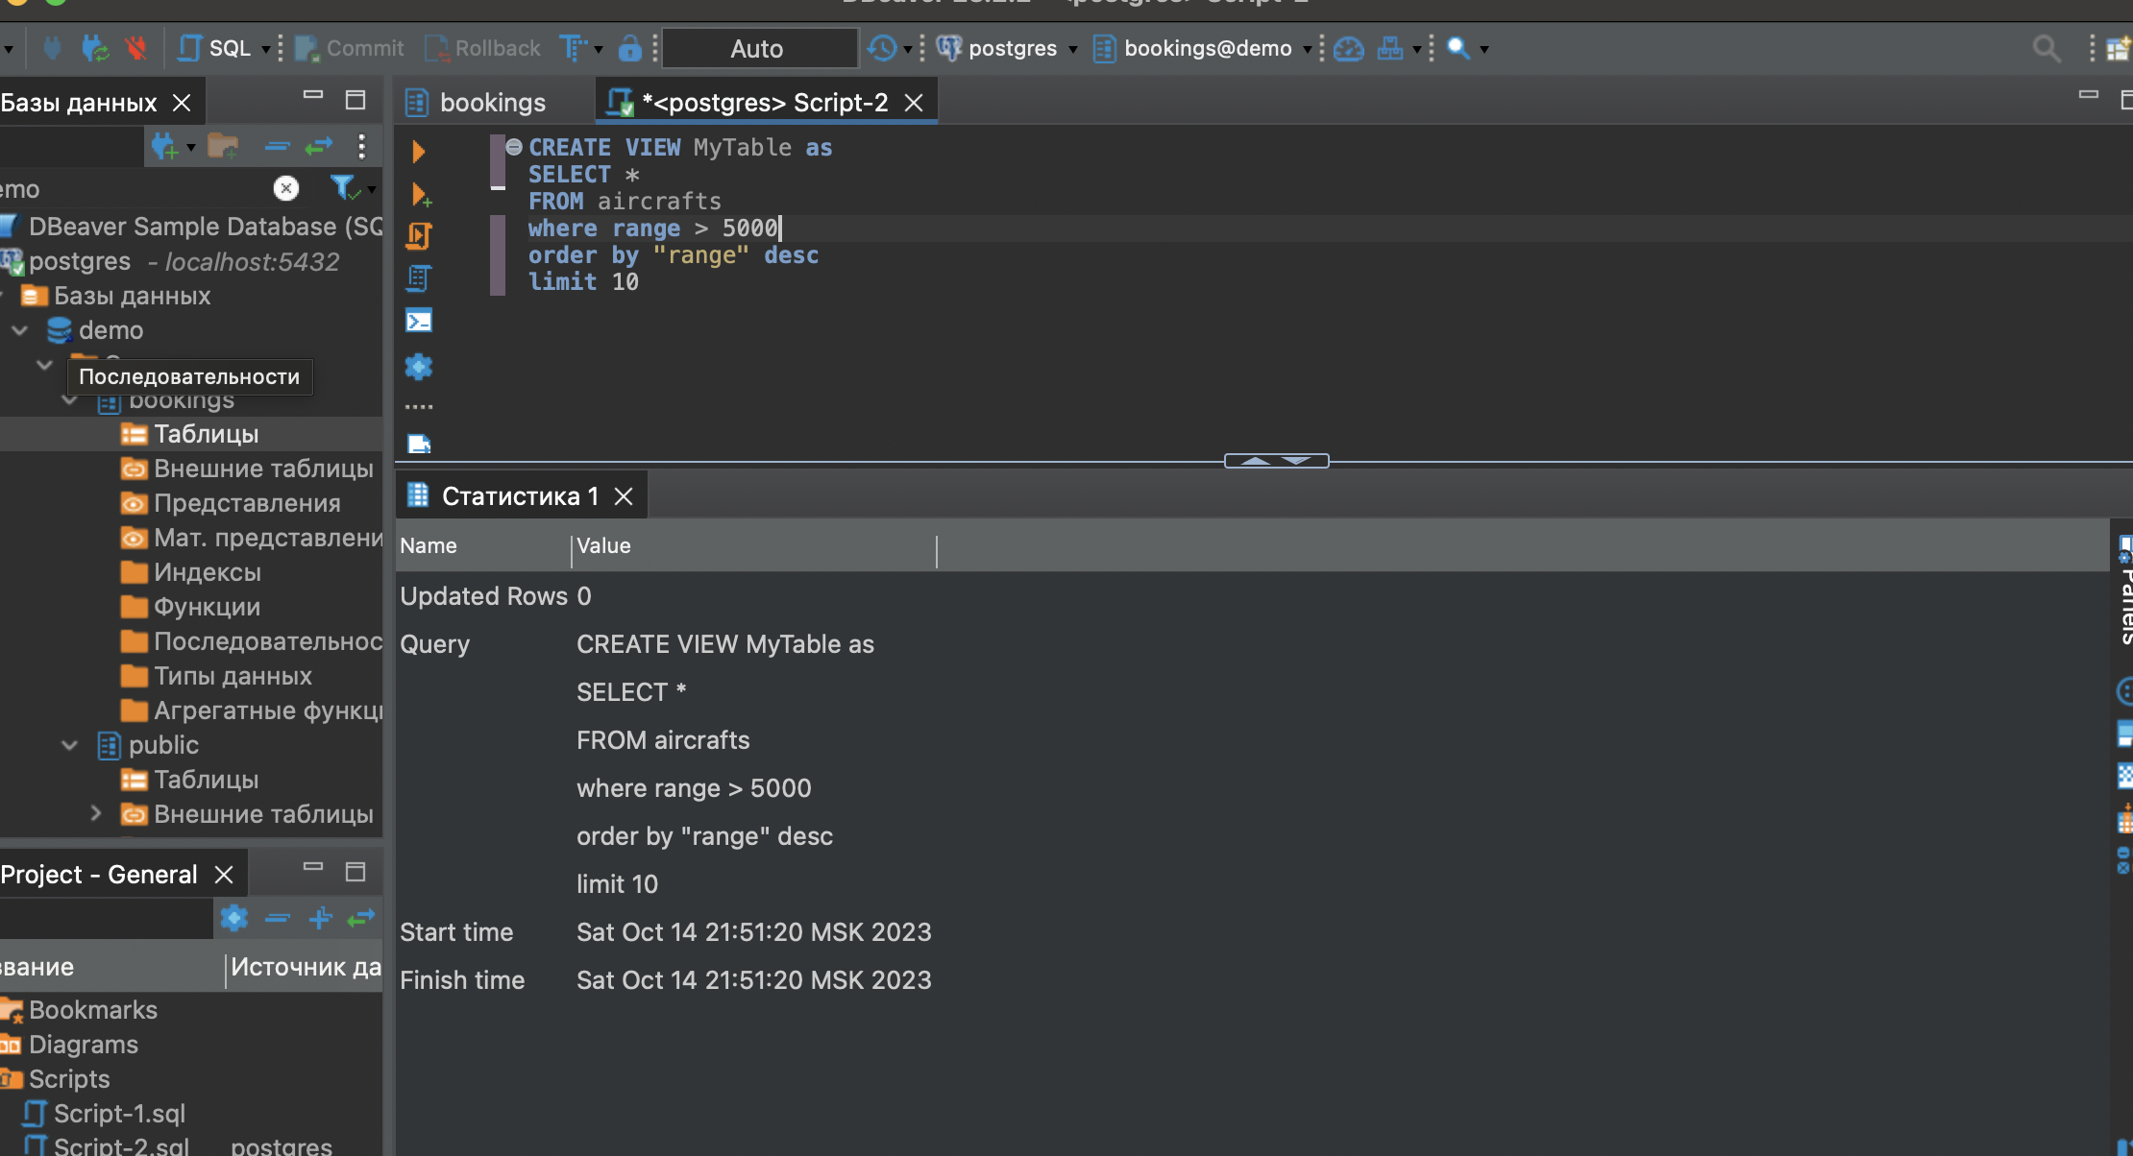

6.

import psycopg2

conn = psycopg2.connect(

database="demo",

user="postgres",

password="590590Aa",

host="localhost",

port="5432"

)

cursor = conn.cursor()

cursor.execute('SELECT * FROM MyTable')

results = cursor.fetchall()

for row in results:

print(row)

cursor.close()

conn.close()